Best K = 2 with mean UMass coherence = 0.335

=== Top words per topic (best model) ===
Topic 0: work, prompts, engineering, skills, prompt engineering, data, design, models, team, language, strong, llm
Topic 1: work, data, models, team, prompts, skills, business, tools, engineering, language, working, solutions

=== Topic prevalence (best K) ===
topic count percent
0 0 60 59.4
1 1 41 40.6
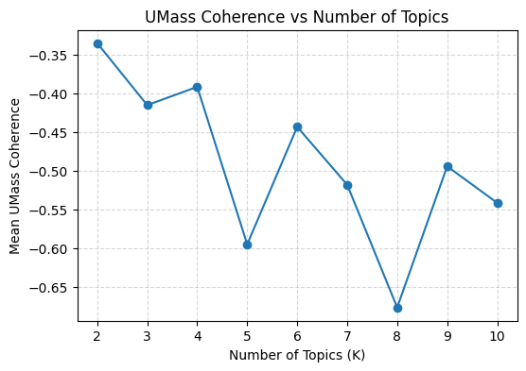
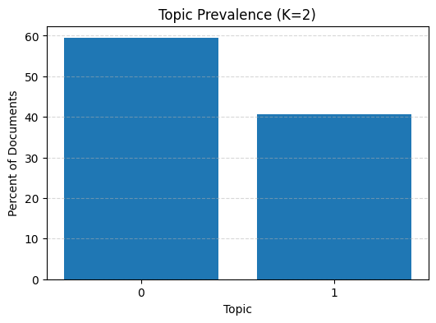

Saved: lda_topics_best.csv, lda_doc_topics_best.csv

